

Children’s Division
Missouri Department of Social Services
PO Box 88
Jefferson City, Missouri 65103
Fax: (573) 526-3971

Re: Derrick Abbott
Incident No. 20212040182

Dear Madam or Sir:

Please consider this a request for a continuance for the administrative review currently scheduled on June 28th, 2022, of the above incident. A request for documentation was emailed on May 25th, 2022, and has not been received by either our office or Mr. Abbott at this time.

Sincerely,

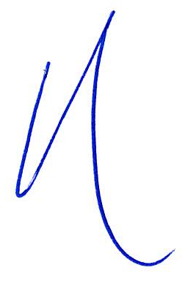
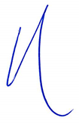

D. Christopher LaPee #63013
75 West Lockwood Avenue
Suite 250
Saint Louis, Missouri 63119
T: (314) 561-9690
F: (314) 596-0658
E: clapee@jcsattorney.com
DCL/taw

